EarthWatcher Technical Report
Cobham Analytic Solutions
January 2010

Overview

EarthWatcher is a tool for visualizing Watcher event streams in the Google Earth GUI. EarthWatcher runs as a daemon on Linux system which creates a file in the Keyhole Markup Language (KML) format. Google Earth reads the KML file and displays the geographic data.

Architecture

EarthWatcher connects to a Watcher server potentially running on another host. It requests events either as live playback, or from the Watcher event database using command line options.

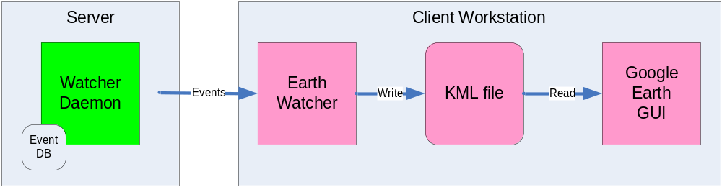
Figure 1. EarthWatcher architecture

EarthWatcher runs as a daemon and maintains a graph of nodes and edges using data contained in the event stream. On a periodic basis, a representation of the current state of the graph is output to a file in the KML format. The Google Earth GUI reloads the KML file periodically. The interval can be configured to match the refresh rate in Google Earth (described below).

In a typical setup, EarthWatcher and the Google Earth GUI will be running on the same host, but this is not a requirement. Google Earth can load KML files using HTTP. If it is desirable to allow multiple Google Earth clients to view the same data, EarthWatcher can be run on a separate host running a web server.

KML Overview

KML is an XML based language for displaying geographic data in a 3D browser, such as Google Earth. It includes features such as drawing points, labels, lines and polygons. Objects can be grouped and organized into folders, similar to directory trees in a filesystem. Each object, as well as folders, also has a visibility attribute which Google Earth uses to selectively display portions of the information in a KML file on the screen, which allows the user to focus on specific objects. Additionally, a KML file may reference other KML files to include as a single logical document. KML references may be on local disk, or specified using the HTTP protocol. This is useful when serving many client machines from the same source data.

A full description of KML can be found at http://code.google.com/apis/kml/documentation/

Interoperating with Google Earth

The Google Earth GUI can read geographic data formatted in KML, either from the local disk, or via HTTP. This is currently the only method of controlling Google Earth since it provides no API for interacting programmatically.

Animation of mobile nodes in the GUI is accomplished by periodically reloading the KML file. Google Earth has an option to automatically reload a file or network link on a configurable basis. Currently the shortest refresh interval is 1 second. Due to the relatively long refresh interval, the animation is not as smooth when compared to the Legacy Watcher GUI.

Google Earth has a built in set of layers, such as Terrain and Political Borders. However, there is no way to add to this set of layers via KML. User defined layers are created as subfolders of My Places in the Places pane. EarthWatcher creates a folder named Watcher that contains all the Watcher related layers. Each layer is a subfolder of the Watcher folder.

Visualizing Layers

Watcher event streams may contain multiple layers of information. For example, a node may have multiple labels, or there might be numerous edges between nodes indicating logically different connections. KML does not provide any attributes that indicate an ordering or priority when there are several objects located in the same space. Google Earth automatically creates a layout. This can lead to more important information being effectively hidden from view because other objects are drawn over it. EarthWatcher solves this problem by stacking the layers vertically using a small offset to the altitude component of the GPS coordinates for objects. Thus, the most important information can be placed at the top of the vertical stack of layers, and Google Earth will ensure it is visible over objects that are in lower layers.

KML allows the altitude component of coordinates to be interpreted in several modes. ClampToGround is the default and means that the altitude is always ignored and the object will be placed on the surface of the Earth. Absolute means the altitude is used exactly as specified, and will be invisible if it falls below the surface of the earth. RelativeToGround means that the altitude component of an object is specified in relation to the Earth’s surface at the given latitude and longitude. For example, an altitude of 10 means 10 feet above the surface of the Earth no matter the absolute altitude.

EarthWatcher uses the RelativeToGound mode when drawing layers. Thus, each layer will appear at the same altitude, contoured to the Earth’s surface.

Edge Modes

EarthWatcher draws a spline between two nodes to represent an edge. The default number of points in the spline is two, which effectively mimcs line of sight. If the surface of the Earth is contoured in such a way that it blocks line of sight between two nodes, the edge will disappear into the Earth’s surface and emerge on the other side of the obstruction. This mode may be desirable when line of sight is a crucial element, such as when modeling radio links. However, for other use cases it may be better to display a continuous line for an edge. EarthWatcher supports this by allowing the default number of points in the spline to be increased. Because each point in the spline uses the RelativeToGround altitude mode (described above), the spline will appear to follow the contour of the Earth’s surface between two points.

KML has a tessellate attribute for lines, which causes lines to follow the contour of the Earth without the need for specifying intermediate points. However, this mode is not compatible with EarthWatcher’s use of altitude offsets for differentiating Watcher layers. Tesselate only works when using the ClampToGround altitude mode.

Multiple Labels

Watcher supports multiple labels on each node or edge. Each label can itself be contained in a different layer. For this reason, EarthWatcher creates a separate Placemark for each label, but hides the associated icon. Only the node in the Physical layer is represented by an icon (with its label hidden). The labels attached to each node will appear to float above the icon depending on which layer they are container in. As previously mentioned, KML does not allow for specified placement of objects, so Google Earth will decide how to lay out objects that exist in the same space. For labels, it attempts to distribute them around the Placemark coordinates in such a manner that all are visible. If labels are in different layers, the topmost label will be centered directly over the node icon.

Outstanding Issues

Google Earth does not preserve the current visibility of folders defined in the KML file across refreshes. Each folder in the Places pane has a checkbox which indicates whether or not the objects contained within are displayed in the image pane. When viewing a static KML file without refresh, this allows the user to select only a portion of the geographic data to be displayed. However, Google Earth does not currently remember the current visibility settings when refreshing the KML file or network link. This is a problem when the refresh interval is short, such as 1 second. This prevents the user from toggling the visibility of layers while animating event stream playback. EarthWatcher works around this issue by checking for changes in the EarthWatcher configuration file and reloading it prior to refreshing the KML file. The EarthWatcher configuration file has settings that allow the user to control the visibility of layers. When the configuration file indicates a layer is hidden, EarthWatcher will omit the folder for that particular layer from the KML file. The next time Google Earth reloads the KML file, the layer should disappear from the image.

Implementation Notes

EarthWatcher is implemented using the following components.

Libwatcher

Libwatcher contains support for Watcher event processing. In particular, EarthWatcher uses the WatcherGraph component for maintaining the current state of the network. This is the same component used by the Legacy Watcher GUI. Libwatcher is part of the Watcher distribution.

Libkml

Libkml is a C++ library for parsing and creating KML documents. It is an open source project developed by Google. Libkml can be found at http://code.google.com/p/libkml/

